Bombardier beetles (Wikipedia)
Bombardier beetles are ground beetles (Carabidae) in the tribes Brachinini, Paussini, Ozaenini, or Metriini—more than 500 species altogether—which are most notable for the defense mechanism that gives them their name: when disturbed, they eject a hot noxious chemical spray from the tip of their abdomen, with a popping sound.
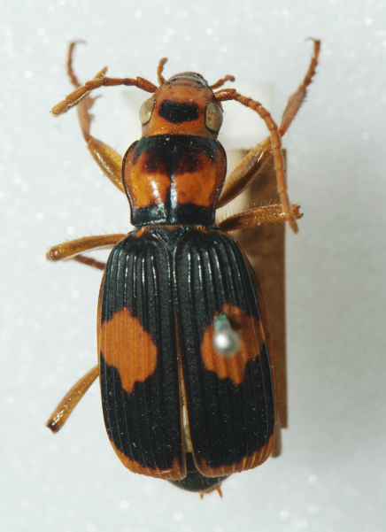
The spray is produced by a reaction between two chemical compounds, hydroquinone and hydrogen peroxide, stored in separate reservoirs in the beetle's abdomen and mixed when needed in a third chamber with water and catalytic enzymes. Heat from the reaction brings the mixture to near the boiling point of water and produces gas that drives the ejection. The damage caused can be fatal to attacking insects and small creatures and is painful to human skin. Some bombardier beetles can direct the spray over a wide range of directions.
Figure 1 Australian Bombardier Beetle (Pheropsophus verticalis)
Habitat … Bombardier beetles inhabit most of the continents, with the exception of Antarctica. They typically live in woodlands or grasslands in the temperate zones but can be found in other environments if there are moist places to lay their eggs.
Behavior … Most species of bombardier beetles are carnivorous, including the larva. The beetle typically hunts at night for other insects, but will often congregate with others of its species when not actively looking for food.
Defense mechanism … The two reactant chemical compounds, hydroquinones and hydrogen peroxide, are secreted by specialized glands and are stored in separate reservoirs in the rear tip of its abdomen. When threatened, the beetle contracts muscles that open the valves of these reservoirs and force the two reactants into a thick-walled mixing chamber lined with cells that produce enzymes including catalases and peroxidases.
In the mixing chamber the enzymes rapidly break down the hydrogen peroxide, releasing free oxygen, and catalyze the oxidation of the hydroquinones into p-quinones.[citation needed] The reaction is very exothermic, and the released energy raises the temperature of the mixture to near 100 C, vaporizing about a fifth of it. The resultant pressure buildup forces the entrance valves from the reactant storage chambers to close, thus protecting the beetle's internal organs. The boiling, foul-smelling liquid partially becomes a gas by flash evaporation and is expelled explosively through an outlet valve, with a loud popping sound.
The flow of reactants into the reaction chamber and subsequent ejection occur in a series of about 70 pulses, at a rate of about 500 pulses per second. The whole sequence of events takes only a fraction of a second.
Typically the beetle turns its body so as to direct the jet towards whatever triggered the response. The gland openings of some African bombardier beetles can swivel through 270° and thrust between the insect's legs, discharging the fluid in a wide range of directions with considerable accuracy.
Evolution of the defense mechanism …
The unique features of the bombardier beetle's defense mechanism—strongly exothermic reactions, boiling-hot fluids, and explosive release–have been used by creationists and proponents of intelligent design theories as examples of irreducible complexity that could not be produced by evolution. However, while the true evolutionary path is still unknown, biologists have shown that the system could in fact have evolved from more ordinary defenses in small incremental steps, by natural selection.
Quinone chemicals are a precursor to sclerotin, a brownish substance produced by beetles and other insects to harden their exoskeleton. Some beetles additionally store excess foul-smelling quinones in small sacs below their skin as a natural deterrent against predators. (It is common in nature for features evolved for one purpose to become used for other purposes, a process called exaptation.) As predators developed resistance to the original quinones, beetles started using other related chemicals such as hydroquinone. In many beetles, specialized cells secrete hydroquinone from glands connected by ducts to a reservoir sac, which can be closed off by muscles to stop leakage.
While all carabid beetles have this sort of arrangement, in some cases, hydrogen peroxide, which is a common by-product of the metabolism of cells, is mixed in with the hydroquinone, and some of the catalases that exist in most cells makes the process more efficient. The chemical reaction produces heat and pressure, and some beetles exploit the latter to push out the chemicals onto the skin. This is the case, for example. of the beetle Metrius contractus, produces a foamy discharge when attacked. In other beetles, the muscles that prevent leakage from the reservoir developed a valve-like flap to ensure that the pressure pushes the discharge out. Natural selection could easily evolve these "ordinary" chemical defenses to the bombardier beetle's mechanism.
Figure 2 Did this evolve? .... or is this design?
Defense mechanism of the Bombardier beetle.
- L- hydroquinones and hydrogen peroxide glands,
- B-Storage reservoirs with hydrochinon and hydrogen peroxide,
- M-Muscle to open the reservoir.
- E- thick-walled mixing/explosion chamber,
- G-Glands with catalases and peroxidases,
From: Crowson, R.A.,
The Biology of the Coleptera, Academic Press, New York, 1981.

